Supplementary Material for Organic & Biomolecular Chemistry
This journal is © The Royal Society of Chemistry 2003

Supplementary data

The Utility of Cyclodextrins in Lipase-catalyzed Transesterification in Organic Solvents: Enhanced Reaction Rate and Enantioselectivity

Ashraf Ghanem
Department of Organic Chemistry, University of Geneva, Quai Ernest Ansermet 30, CH-1211 Geneva 4, Switzerland.
Author e-mail: ashraf.ghanem@chiorg.unige.ch
Phone: +41(0) 22-7026441, Fax: +41(0) 22-3442749

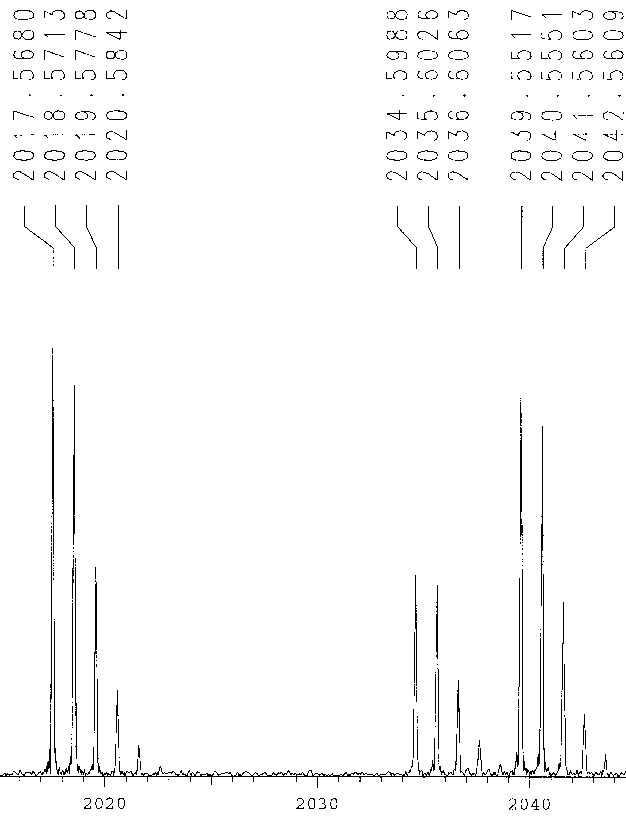
Positive Ion FAB Mass Spectrum of peracetylated-β-cyclodextrin. Expected masses [M+H]⁺ =2017.59; [M+Na]⁺=2039.58; [M+NH₄]⁺= 2034.62.

(R)-3
(S)-1
(R)-1
(S)-3
(R)-3
(S)-1
(R)-1
(R)-3
(S)-1
(R)-1

Fig. a Fig. b Fig. c

Gas-chromatographic separation of the enantiomers of both substrate (1) and product (3) on heptakis-(2,3-di-O-methyl-6-O-tert-butyldimethylsilyl)-β-cyclodextrin of the co-lyophilized PSL with peracetylated-β-cyclodextrin-catalyzed transesterification of (1) in toluene at t=1 hr. Fig. a: 1:1 enzyme/Ac-β-cyclodextrin weight ratio, ee_{s} =4.5%, ee_{p}=99%, conv. =4.5%, E >100; Fig. b: 1:2 enzyme/Ac-β-cyclodextrin weight ratio, ee_{s}=5%, ee_{p} =99%, conv. =5%, E>100; Fig. c: 1:6 enzyme/Ac-β-cyclodextrin weight ratio, ee_{s} =25%, ee_{p}=99%, conv. =20%, E>100. The retention time of (S)-3, (R)-1, (S)-1, (R)-3, were 14.7, 15.5, 16.8, 20.2 min, respectively.

(S)-1
(R)-3
(S)-1
(R)-1
(R)-3
(R)-1
(S)-1
(R)-3
(S)-3
(R)-1

Fig. a Fig. b Fig. c

Gas-chromatographic separation of the enantiomers of both substrate (1) and product (3) on heptakis-(2,3-di-O-methyl-6-O-tert-butyldimethylsilyl)-β-cyclodextrin of the co-lyophilized PSL with peracetylated-β-cyclodextrin-catalyzed transesterification of (1) in toluene at t=2 hrs. Fig. a: 1:1 enzyme/Ac-β-cyclodextrin weight ratio, ee_{s} =7.3%, ee_{p}=96%, conv. =7%, E =54; Fig. b: 1:2 enzyme/Ac-β-cyclodextrin weight ratio, ee_{s}=9%, ee_{p} =99%, conv. =8%, E>100; Fig. c: 1:6 enzyme/Ac-β-cyclodextrin weight ratio, ee_{s} =70%, ee_{p}=98%, conv. =42%, E>100.
The retention time of (S)-3, (R)-1, (S)-1, (R)-3, were 14.7, 15.5, 16.8, 20.2 min, respectively.

(R)-3
(S)-1
(R)-1
(S)-3
(R)-3
(S)-1
(R)-1
(S)-3
(R)-3
(S)-1
(R)-1
(S)-3

Fig. a Fig. b Fig. c

Gas-chromatographic separation of the enantiomers of both substrate (1) and product (3) on heptakis-(2,3-di-O-methyl-6-O-tert-butyldimethylsilyl)-β-cyclodextrin of the co-lyophilized PSL with acetylated-β-cyclodextrin-catalyzed transesterification of (1) in toluene at t=6 hrs. Fig. a: 1:1 enzyme/Ac-β-cyclodextrin weight ratio, ee_{s} =8%, ee_{p}= 86%, conv. =9%, E =15; Fig. b: 1:2 enzyme/Ac-β-cyclodextrin weight ratio, ee_{s}=14%, ee_{p} = 84%, conv. =14%, E =13; Fig. c: 1:6 enzyme/Ac-β-cyclodextrin weight ratio, ee_{s} = 91.5%, ee_{p}=84.5%, conv. = 50%, E = 38
The retention time of (S)-3, (R)-1, (S)-1, (R)-3, were 14.7, 15.5, 16.8, 20.2 min, respectively.

(R)-3
(R)-3
(R)-3
(S)-1
(S)-1
(S)-1
(R)-1
(R)-1
(S)-3
(S)-3
(S)-3

Fig. a Fig. b Fig. c

Gas-chromatographic separation of the enantiomers of both substrate (1) and product (3) on heptakis-(2,3-di-O-methyl-6-O-tert-butyldimethylsilyl)-β-cyclodextrin of the co-lyophilized PSL with acetylated-β-cyclodextrin-catalyzed transesterification of (1) in toluene at t=8 hrs. Fig. a: 1:1 enzyme/Ac-β-cyclodextrin weight ratio, ee_{s} =14%, ee_{p}=94%, conv. =13%, E =39; Fig. b: 1:2 enzyme/Ac-β-cyclodextrin weight ratio, ee_{s}=14%, ee_{p} =94%, conv. =13%, E=38; Fig. c: 1:6 enzyme/Ac-β-cyclodextrin weight ratio, ee_{s} =99.9%, ee_{p}=79.1%, conv. =56%, E=88. The retention time of (S)-3, (R)-1, (S)-1, (R)-3, were 14.7, 15.5, 16.8, 20.2 min, respectively.

